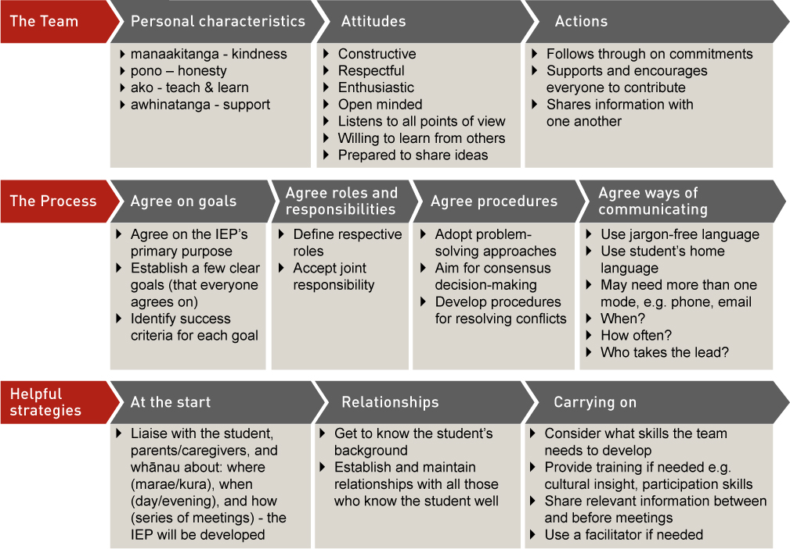
The Team
  Personal characteristics | Attitudes | Actions
  - Maanakitanga – kindness  - Pono – honesty  - ako - teach & learn  - awhinatanga - support | - Constructive  - Respectful  - Enthusiastic  - Open minded  - Listens to all points of view  - Willing to learn from others  - Prepared to share ideas | - Follows through on commitments  - Supports and encourages everyone to contribute  - Shares information with one another
The Process
  Agree on goals | Agree roles and responsibilities | Agree procedures | Agree ways of communicating
  - Agree on the IEP’s primary purpose  - Establish a few clear goals (that everyone agrees on)  - Identify success criteria for each goal | - Define respective roles  - Accept joint responsibility | - Adopt problem-solving approaches  - Aim for consensus decision-making  - Develop procedures for resolving conflicts | - Use jargon-free language  - Use student’s home language  - May need more than one mode, e.g. phone, email  - When?  - How often?  - Who takes the lead?
Helpful strategies
  At the start | Relationships | Carrying on
  - Liaise with the student, parents/caregivers, and whānau about: where (marae/kura), when (day/evening), and how (series of meetings) - the IEP will be developed | - Get to know the student’s background  - Establish and maintain relationships with all those who know the student well | - Consider what skills the team needs to develop  - Provide training if needed e.g. cultural insight, participation skills  - Share relevant information between and before meetings  - Use a facilitator if needed

