Carol Ann  Children’s Ward  Hawke’s Bay Hospital  Private Bag 9014  HASTINGS  Ph (06) 870 6548  Fax (06) 870 6558  Email:  Carol-ann@centralregionalhealth.school.nz |  | CENTRAL REGIONAL HEALTH SCHOOL  INDIVIDUAL EDUCATION PLAN  For: Zephi Princton  Date: 26.1.11 |  | 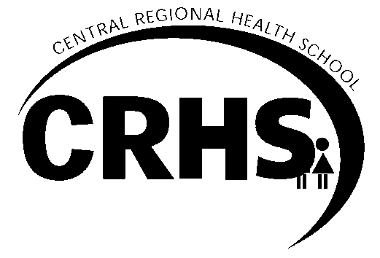
Previous IEP dates | 16.2.09, 6.4.09, 25.5.09, 13.10.09, 12.11.09, 19.2.10, 18.3.10, 16.9.10, 1.11.10 |  | Withdrawal date:

Name: Zephi Princton  DOB: 13.9.94  Phone: 877 7777  Address: 52 Archers Rd  Central Regional Health School  and: WBHS  Year: 12 | Meeting Date 26.1.11  Location: WBHS  Review Date: 28.3.11 9.35am  Long term aim: For Zephi’s education to continue until such time as she is able to return to school fulltime.  Date of admission: 16.2.09  Criteria on entry: C2  Admission No: 09/011 NSN: 130606133 | Team Members Contributing: Zephi  Parents: Sarah and Indie Princton  WBHS SENCO: Jane Fredricks  WBHS: Sally Phoenix  CRHS Teacher: Carol Ann  Other: Te Kura teachers
  Phone: 888 8888 | Fax: 888 8888
Health Information: Zephi has Chronic Fatigue. This condition causes her to be fatigued much of the time and to have daily headaches and pains. By being very determined, Zephi is able to work for part of the day. It is anticipated that her health condition will gradually improve; there has been some improvement in the last year.

Present skills and needs: Zephi is a very able student who has made an impressive effort to continue her education despite her health condition. She gained 116 NCEA L1 credits in 2010. Zephi has a good understanding of how her health condition effects her ability to work, and has developed excellent study skills to make the most of the time she is well enough the work. Zephi is making a huge step forward in attempting to attend WBHS classes for both Chemistry and Physics this year. Zephi has everyone’s best wishes and support to do this.
Transition: Zephi is going to begin transitioning back to school part time in February, attending Chemistry and Physics classes. If Zephi’s health makes this too hard, attending Chemistry classes will be her priority.

Copies to: Sarah, Indie and Zephi Princton, Jane Fredricks, Sally Phoenix, Kate Sprinkle (Y12 Dean) Ken McIntosh (CRHS principal), Keith Connor (CRHS/TeKura liaison), file.

Student name: Zephi Princton  Teacher name: Carol Ann  Date: 26.1.11 | CENTRAL REGIONAL HEALTH SCHOOL  INDIVIDUAL EDUCATION PLAN

Key Competencies and Goals |  | Learning Facilitators, Resources etc.
Curriculum Areas  As set by Te Kura for:  BY200 Biology  EN200 English  HE200 Home and Life Sciences  MX200 Maths  Outcomes:  - Complete Te Kura booklets in each subject within an expected timeframe and to a high standard.  As set by WBHS for:  CH200 Chemistry  PX200 Physics  Outcomes  - Attend and participate in classes.  - Complete work within an expected timeframe and to a high standard. | Managing Self  Use strategies for meeting challenges.  Outcomes:  - Continue monitoring how her health is affecting her ability to work.  - Use and refine strategies to meet challenges. | Zephi will:  - Attend WBHS for Y12 Chemistry and Physics classes.  - Sign in and out at the office.  - Collect the Daily news from the office when she signs out.  - Go to the Travers Centre, or stay in the physics classroom, during lunchtime on the day she has a class before and after lunch.  - Complete Te Kura booklets at the required rate to ensure the courses are completed in the year.  - Complete Home and Life Sciences during the school holidays.  - Monitor her workload and decide in the first few weeks whether to continue with Biology.  Zephi’s family will:  - Be responsible for transporting Zephi to school.  - Be responsible for transporting Zephi from school in the afternoons, and any mornings not covered by Carol Ann.  - Support and encourage Zephi to complete work set. | Jane will:  - Be Zephi’s WBHS contact teacher.  - Meet informally with Zephi on her first day of school.  - Tell the office staff that Zephi will be collecting the Daily News when she signs out each day.  - Ask her secretary, Sandra, if she could transport Zephi home if, on a mostly like very rare occasion, other options are not available.  Carol Ann will:  - Collect Zephi from WBHS on Monday and Thursday at 9.35am, transport her home then teach for one hour.  - Collect and return booklets and help with any areas of difficulty.  - Help Zephi prioritise work.  - Liaise with the WBHS and Te Kura teachers.
Evaluation:

